**Database Evaluator Guide**

**Step 1 : Copy the needed files to run the Database Evaluator.**

**This includes:**

**a) itextsharp.dll – The C# library used for creating PDF Reports**

**b) DatabaseEvaluator.exe – The application developed by the team to produce PDF reports based on the dump file provided by the user**

**c) FinalEvaluator.sql – The SQL file containing the scripts used in the evaluation proper**

**d) instance.txt – The text file containing the name of the SQL Server Instance which has all the information needed to do the evaluation**

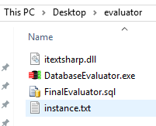

**Step 2 : Run DatabaseEvaluator.exe as an Administrator and the evaluator screen should load**

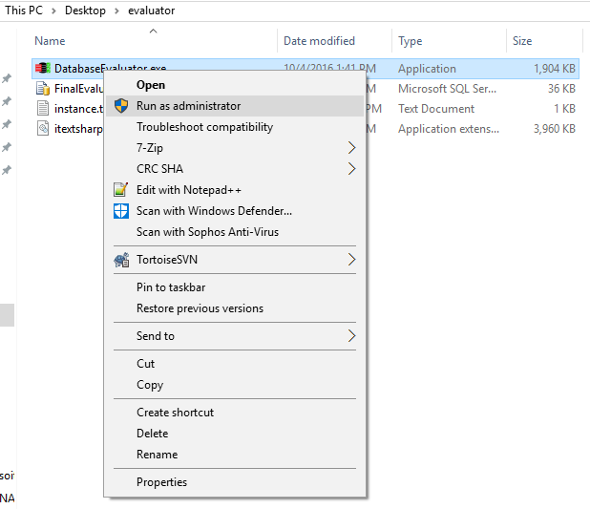

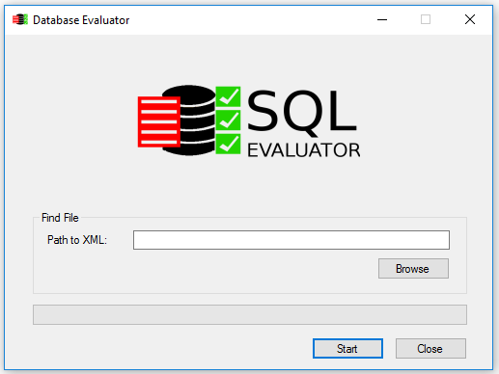

**Step 3 : Click on the Browse button and select the .dbe file which contains the SQL Parameters to be evaluated**

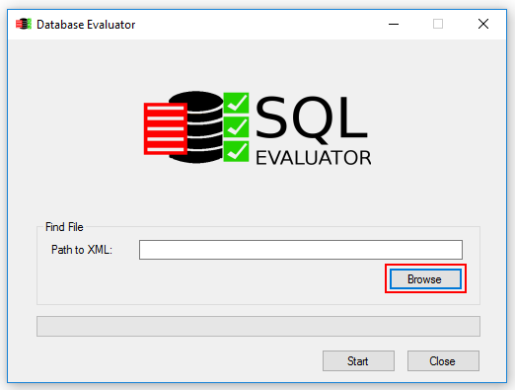

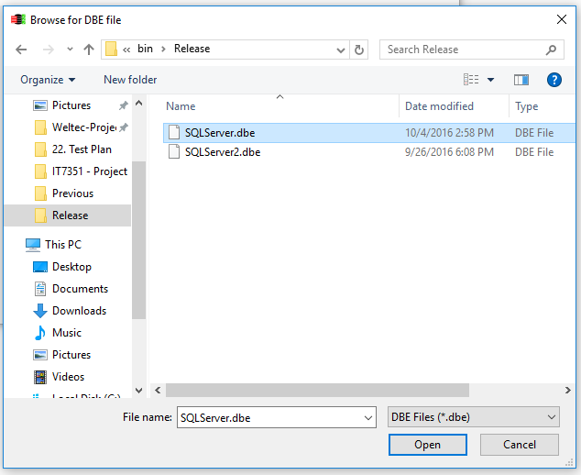

**Step 4 : The path to the dbe file should now be visible and you can now click on Start to do generate the PDF Report**

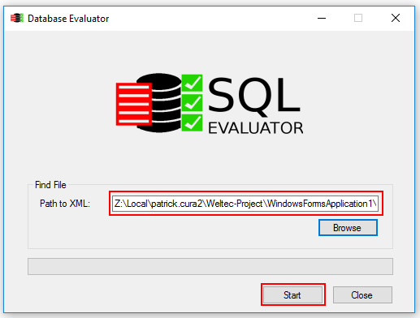

**Step 5 : Once the report is ready, you can now save it**

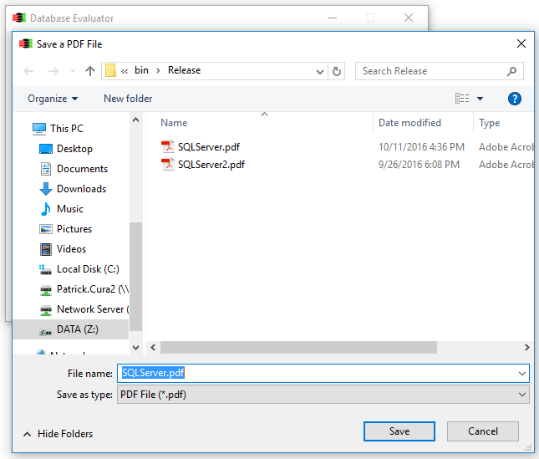

**Step 6 : Go to the location where you saved the report and verify its contents**

